Safe and Supportive Schools Framework
Implementation Guide and Self-Reflection Tool

The Safe and Supportive Schools (SaSS) Framework and Self-Reflection Tool offers a comprehensive process for school teams to use in collaborative reflection, planning and implementation efforts. For more details see this video or this feedback page.
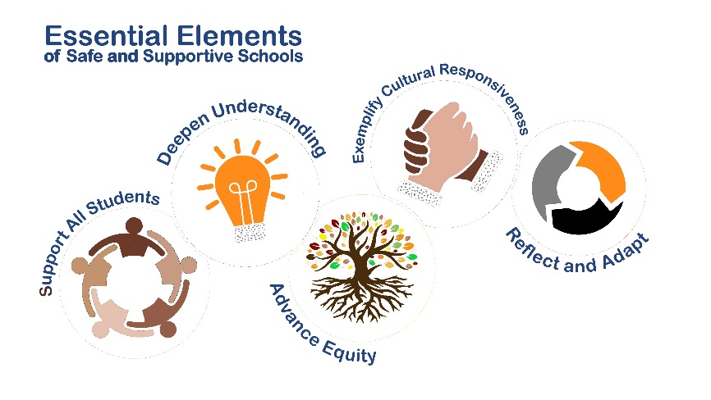

The foundation for the
SASS Framework are the
Essential Elements of a
Safe and Supportive School
A Five-Phase Approach to Creating a Safe and Supportive School
The SaSS Framework guides school-based teams through a phased process to create plans based on their local context through a data informed examination of student needs and opportunities, school operations, personnel, processes, policies, family connections, and community services and partnerships available to create a safer and more supportive school climate and culture.
The process supports a locally run approach for school teams to lead the entire staff to develop a deeper awareness of the benefits of the Essential Elements of a safe and supportive school, and the need to make their own school safer and more supportive.
There are six defined Implementation Levers which include guiding questions and rubrics that speak to a number of areas of school operation in which to focus the planning, implementation, and continuous improvement of initiatives, activities, and other work associated with a school’s implementation of the SaSS Framework.
Implementation Levers

The Essential Elements are used as Indicators within each of the Levers to help teams gauge how each of them is in evidence within a school, and where progress needs to be made to improve conditions and outcomes for students, staff, families, and communities.
The Self-Reflection Tool is aligned to the Implementation Levers and has two parts. The Preliminary Self-Reflection is for teams to use during Phase I to explore how the Essential Elements are currently being practiced or are already embedded in the school, and where gaps exist – and to consider priority areas for greater focus. During Phase II, the planning team uses the Deeper Dive Self-Reflection to identify areas where additional school-based action, efforts, guidance, and support are needed to create, expand upon, and maintain safe and supportive schools.
SaSS Self-Reflection Tool

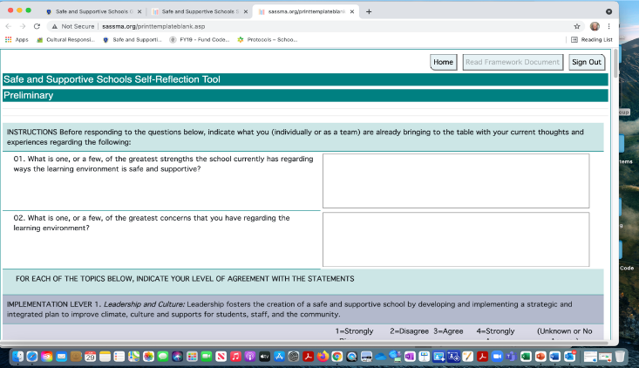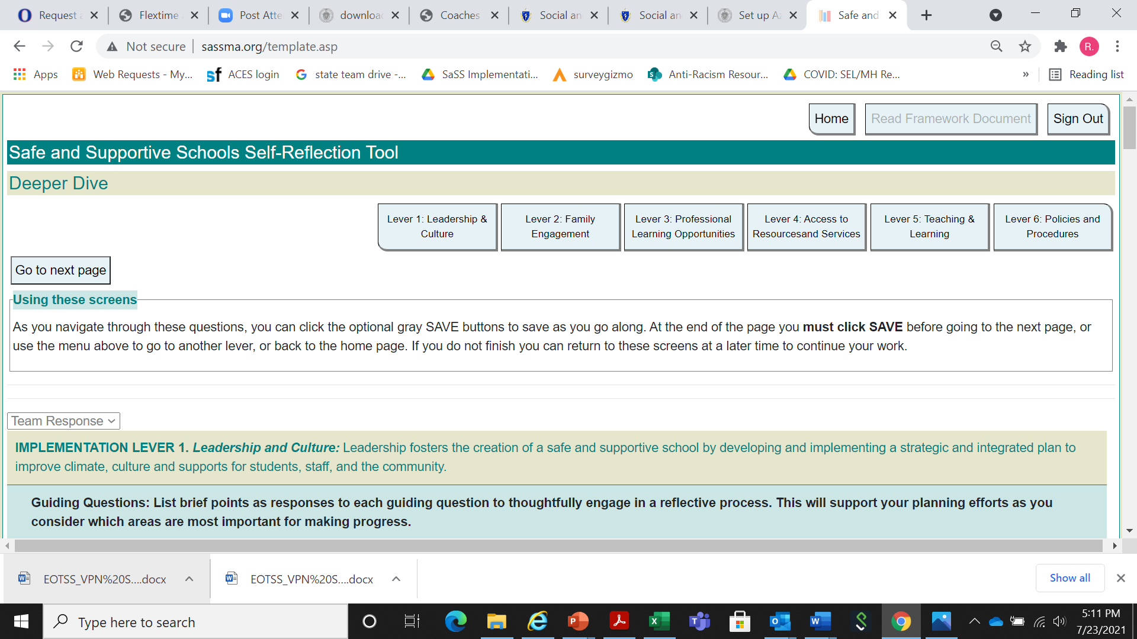
The self-reflection tool is designed to inform Action Planning (Phase III) and Implementation efforts (Phase IV). This work is intended to be a part of ongoing Cycles of Continuous Inquiry and Improvement (Phase V).
Together the Safe and Supportive Schools Framework Implementation Guide and Self-Reflection Tool provides a thoughtful and inclusive process for districts and schools to use to examine current operations; identify strengths, challenges, and growing edges; and create, implement, and assess concrete plans to improve school climate, culture, and safety for every student from every identity and background – and to support all staff, families, and partners too.

